How to deal with FULL Mailbox in Outlook
Situation: if your mailbox is full assuming that you are Microsoft 365 user.
Task: Need to backup your email history properly and delete the old ones in your current mailbox.
Action:
- Backup your old emails by folders
- Open Outlook app, go to File> Open & Export> Import/Export
- In Import and Export Wizard, Click on Export to a file> Outlook Data File (.pst)
- In Export Outlook Data File, select each folder to backup one by one.
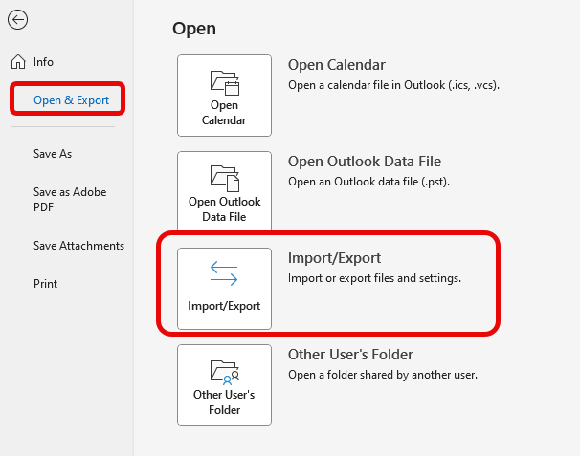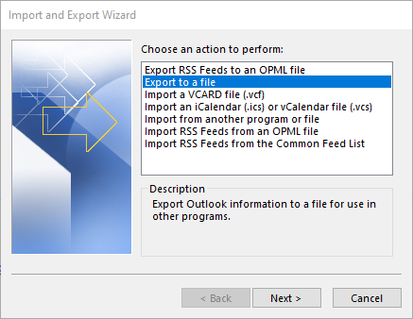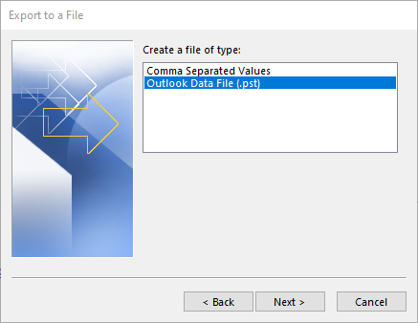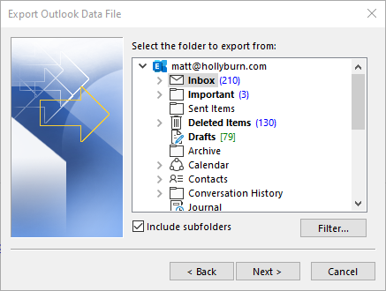

- Saving backup in the cloud
- After exporting the file into .pst, upload the physical file to the sharepoint or contact IT.
- Also keep a copy of the file in your desktop folder so you can access the old email once needed.
- Delete old emails
- After the backup is completed, go to outlook web : https://outlook.office.com/mail/
- Go to Setting by clicking the gear icon on the top right’
- General> Storage, in Manage Storage tab, delete emails in the folders by selecting 12 months and older. Make sure the deleting emails in the folders are the one you had backup before.
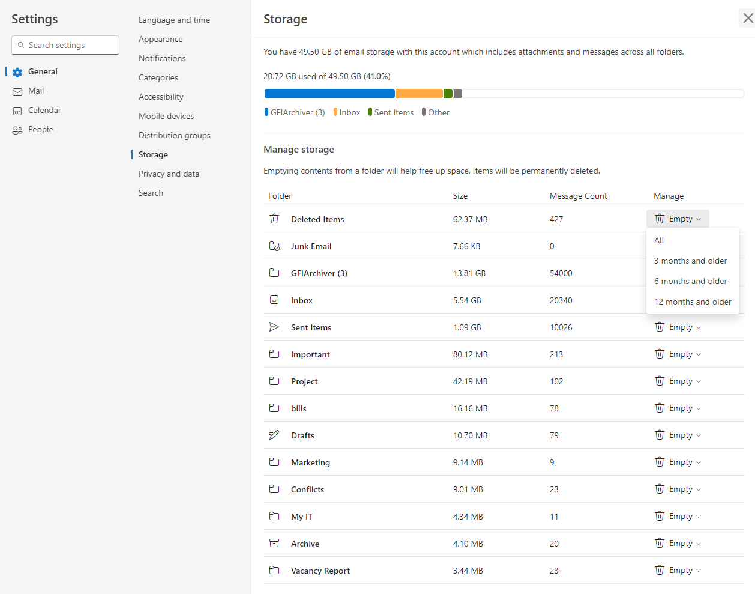

- To get an access to the old email from backup pst file.
- Open Outlook app and File> Open & Export> Open Outlook Data File
- Upload the backup pst file here
- The new backup email will be showing as an account in the left sidebar
- 