Changing the name on the email signature
Situation: You just are assigned to the new property but the signature name shown in the property’s account still has the old manager’s name.
Ex) Nicola Place -> Matt Kim
Task: Need to update only the first and last name of the account but leave the display name as the building name.
How to:
- Open a browser and go to Exchange Admin Center: https://admin.exchange.microsoft.com/
- Sign in using your account email credentials.
- Go to Account> Manage Information> Manage general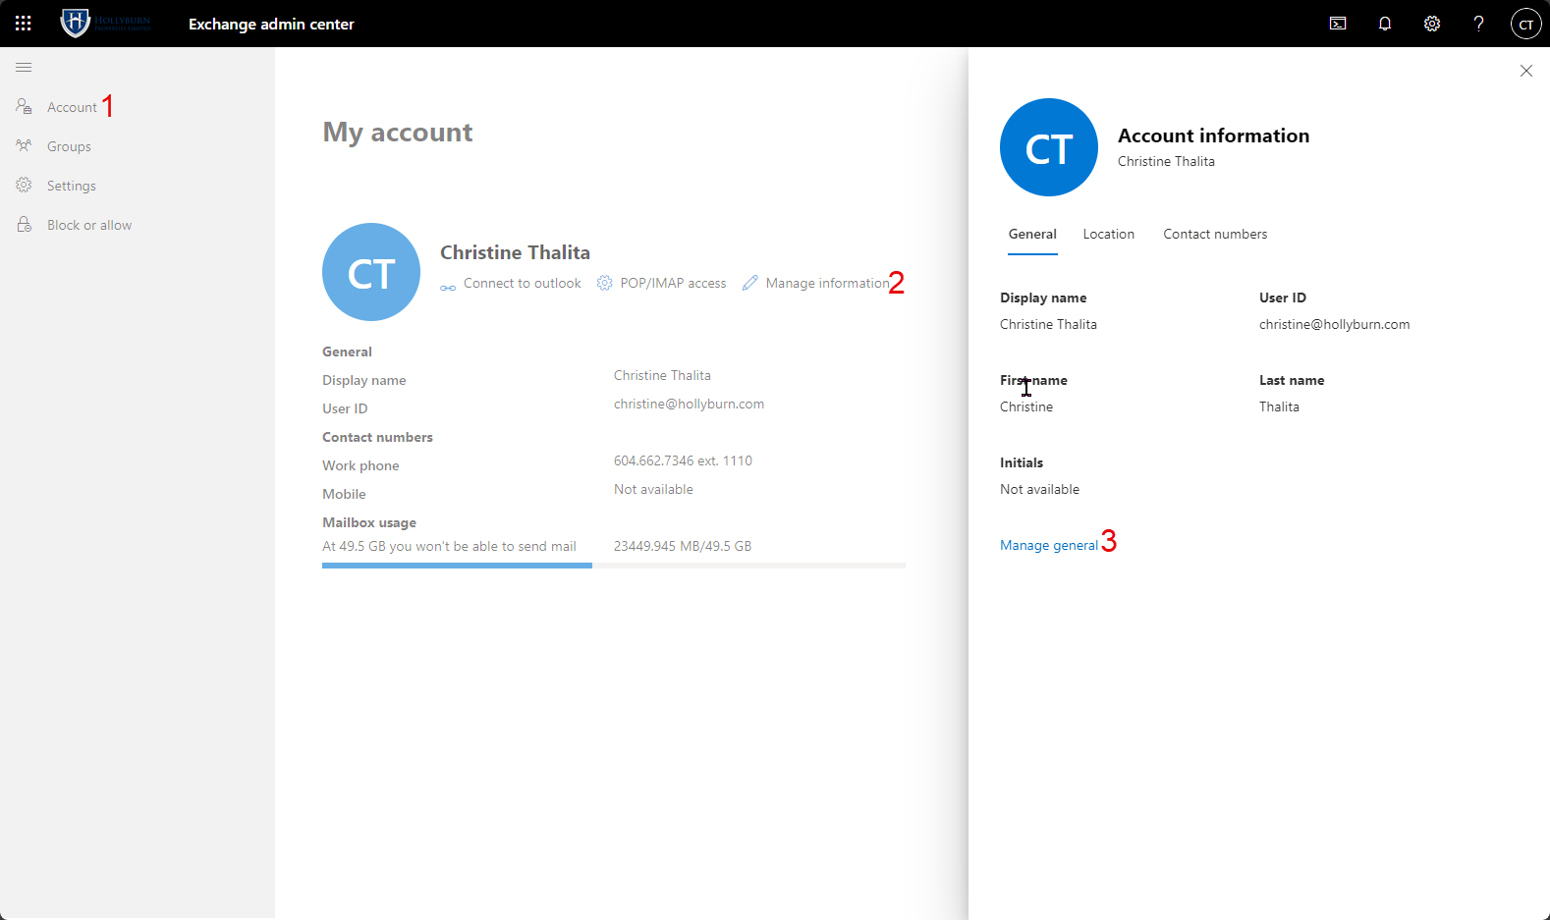
- In Manage general, please update only the FIRST NAME and LAST NAME. Leave the display name as the building name and click Save
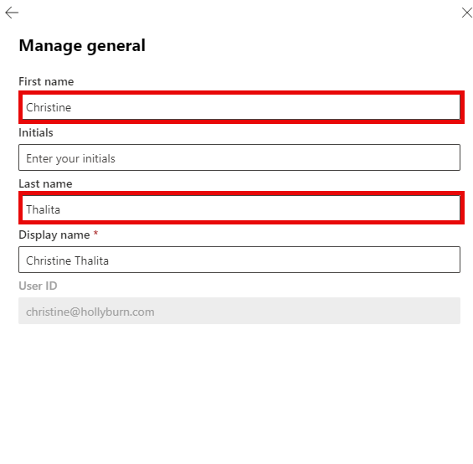
- Done

